One Time Run Scripts Executional Steps

OTR Scripts Execution Procedure |  |  | Issued Date :26/05/2021
Version | Date |  | Description of changes
1.0 | 26/05/2021 |  | Initial Version
Responsible
Developers:  Infosys Team |  | Reviewer:  Infosys

Contents
Introduction to OTR 3
Difference with IL (Initial Load) 3
Difference with Delta 3
Preparatory Actions 3
Logic Inside the OTR Scripts 3
How to calculate what to enter in TimeVariant.txt for OTR? 4
Introduction to Delta 5
Logic Inside the Delta Scripts 5
How to calculate what to enter in <Type>.txt for Delta? 5

Introduction to OTR
OTR (One-Time Run) scripts are scripts developed to address specific data extraction needs to allow for indexing specific data demand.

Difference with IL (Initial Load)
- IL scripts are executed at first time indexing while OTR can be at any point in time
- IL scripts consider ONLY Release data (under usual circumstances), while OTRs could consider Release and Obsolete.

Difference with Delta
- Delta runs every 3 mins, while OTR is on-demand (upon need).

Preparatory Actions
The below table describes the steps that needs to be taken as part of the setup of the OTR scripts.
Step # | Action | Paths
Step 1 | Confirm that all the latest OTR files from GIT are available on the MQL servers at {InstallPath} | {InstallPath}:  - /mnt/mql/OTR (on linux)  - F:\ObjectDataExtraction\OneTimeRun_Delta (on Windows).
Step 2 | Update User password (as relevant on the environment) | File to update:  {InstallPath}/setOPSVariables (.sh or .bat based on OS)
Step 3* | Set the time stamp from when the OTR is to be executed | File to update:  {InstallPath}/Input/TimeVariant.txt

*Step 3 is critical and DIFFERS in value to set between OTR and delta. The file exists at the below location:

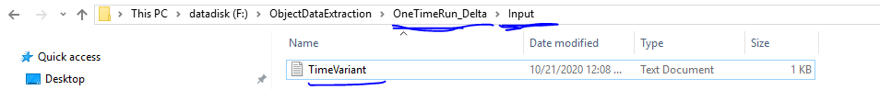
Figure 1 TimeVariant file (Dev env screenshot)

Logic Inside the OTR Scripts
Below are the lines of code that read this value:
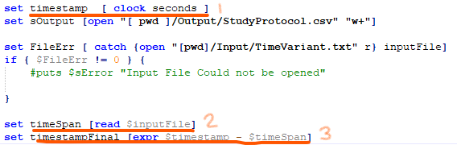
Figure 2: Timestamp calculation code

How to calculate what to enter in TimeVariant.txt for OTR?
Remember: The value to be entered is to be in seconds.
Things to remember:
- 1 minute 60 seconds
- 1 hour = 60 minutes = 60 x 60 3600 seconds
- 1 day = 24 hours = 3600 x 24 86400 seconds
Example 1: What would the value to be entered in the TimeVariant.txt be, if you need to run the indexing for the last 24 hours?
OTR consideration for time is based on time difference from current. As can be seen from the table above, if you wish to run the OTR for the last 24 hours, the entry in the file should be 86400 seconds.
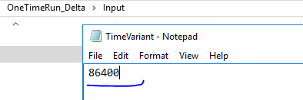
Figure 3: Value for 24 hours in seconds entered in TimeVariant.txt
Example 2: What would the value to be entered in the TimeVariant.txt be, if you need to run the indexing for the last 5 days?
As the data needed is for the last 5 days, the calculation would be:
5 days = 5 x 1 day = 5 x 24 hours = 5 x 24 x 60 mins = 5 x 24 x 60 x 60 seconds
- 432000 seconds
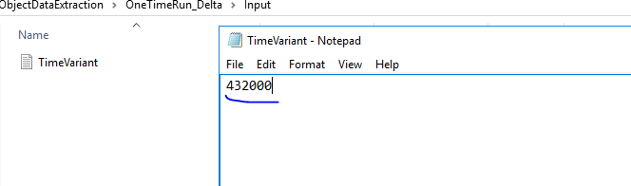
Figure 4: Value for 5 days in seconds entered in TimeVariant.txt
Input changed to 432000, we will get data extracted for last 5 days.
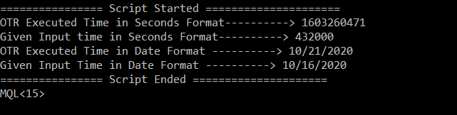
The screenshot shows the timestamp generated by the OTR script when launched on 21st Oct’20. As can be seen, the script considers previous 5 days (i.e. from 16th Oct’20)

Introduction to Delta
Delta scripts were developed to address indexing of data created in near real-time (launched every 3 mins triggered by cron).
The preparatory steps for Delta are similar to those of OTR. The install path here is /mnt/mql/Delta
The main difference, however, is in how “Time Variant.txt” (here EACH type has its OWN txt file) is understood by the Delta script.

Logic Inside the Delta Scripts
Below are the lines of code that read this value:
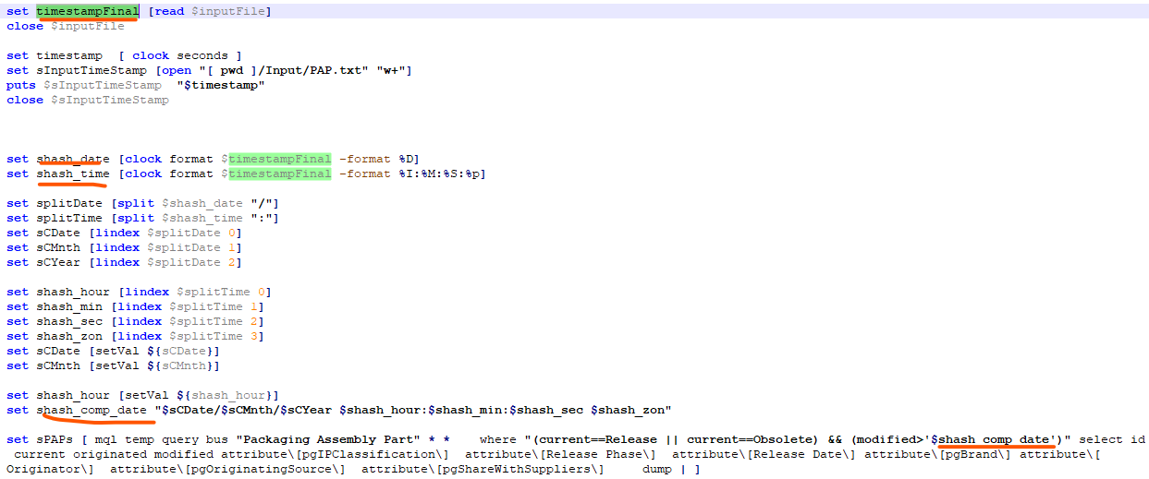
Figure 5: Delta Timestamp calculation code
Note: Here as well the entry is in seconds. However, as can be seen from the code snippet, the entry in the <Type>.txt for Delta is the Unix time (also known as Epoch time, POSIX time) in seconds (i.e., dd/mmm/yyyy hh:min:ss represented in seconds).

How to calculate what to enter in <Type>.txt for Delta?
In order to identify the Unix time (also known as Epoch time, POSIX time of any day in seconds, you can use websites like https://www.unixtimestamp.com/index.php or https://www.epochconverter.com/ .
Note: OTR calculation WILL NOT work here for Delta.
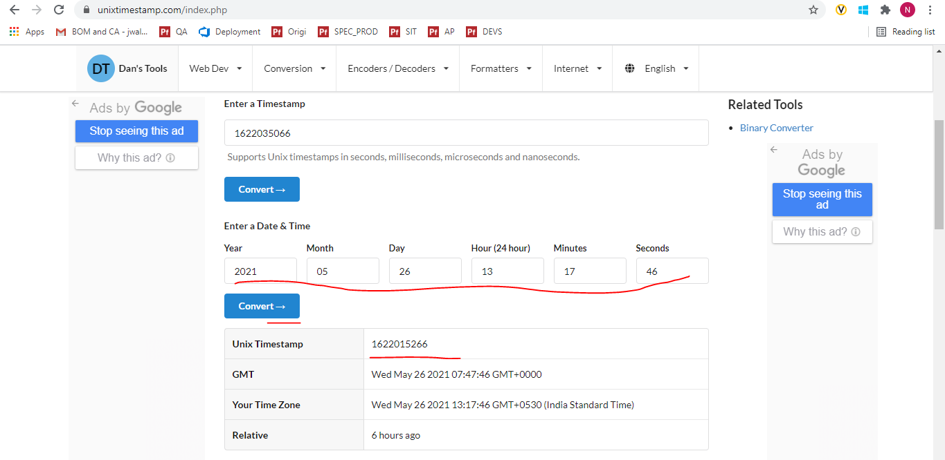
Example 1: What would the value to be entered in the TimeVariant.txt be, if you need to run the indexing via Delta from Friday, October 16, 2020 12:00:00 AM?
In order to extract data starting from Friday, October 16, 2020 12:00:00 AM, goto any epochconverter website
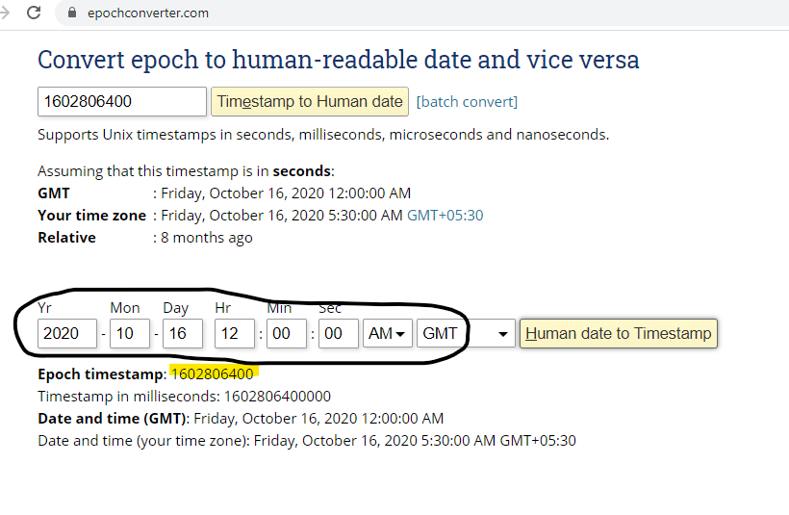
Figure 6: Convert Human readable date to Unixtime
As can be seen from the screenshot above, the epoch timestamp is 1602806400 which is the value to be placed in the FOP.txt
Example: FOP.txt
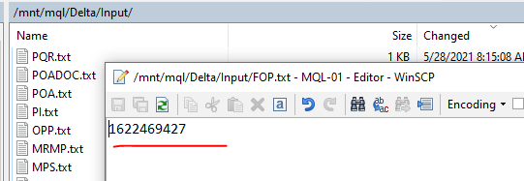

**End of Document**

